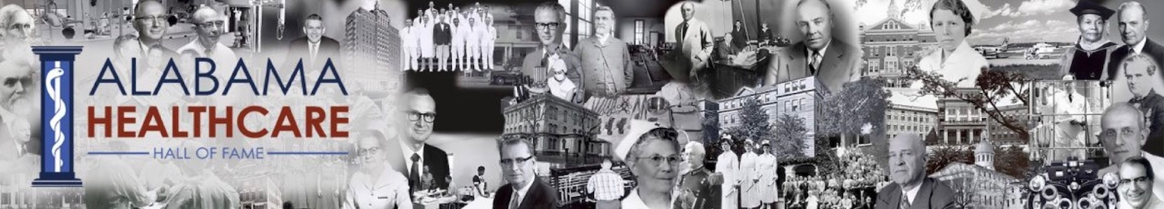
For Immediate Release
Contact: Abby Vinson abbycvinson@gmail.com
Alabama Healthcare Hall of Fame to induct 12 healthcare giants
Birmingham, Ala. – The Alabama Healthcare Hall of Fame will recognize 12 prominent healthcare leaders this year, including the president of UAB, a number of accomplished physicians and dentists, a hospital executive, a post-acute care executive, a dean of nursing, and accomplished researchers.
They will be inducted into the Healthcare Hall of Fame at a ceremony Aug. 8 in Montgomery
“This is a diverse group of individuals who have unique contributions to healthcare in the state of Alabama and beyond,” said Christy Harris Lemak, PhD, chair of the Hall of Fame Board. “We are proud to recognize them and to add them to the select group of people who have earned this honor.”
The Alabama Healthcare Hall of Fame was founded in 1997 to recognize people, living and dead, who have made outstanding contributions and provided exemplary healthcare service in the state.
The Hall of Fame Class of 2026 includes:
- James Andrews, MD, orthopedic surgeon and founder of Andrews Sports Medicine.
- Clarence M. Ball, Jr., LNHA, president and CEO of Ball HealthCare Services.
- Benjamin Joseph Cumbus, DMD, pediatric dentist in Montgomery.
- Carlos "Carl" O. Garner, PhD, vice president of global regulatory affairs for Eli Lilly.
- L. Keith Granger, Alabama CEO for Community Health Systems.
- The late J. Jack Kirschenfeld, MD, professor of UAB School of Medicine and director of the Montgomery Internal Medicine Residency Program.
- The late Robert A. Kreisberg, MD, chairman of the Department of Medicine at the University of South Alabama Hospital.
- Wickliffe J. Many, MD, dean of medicine for the UAB School of Medicine Montgomery Regional Medical Campus.
- Mark R. McIlwain, DMD, MD, oral surgeon and co-owner of Oral and Facial Surgery of the Shoals.
- Dr. Dennis G. Pappas, MD, board certified physician in otolaryngology and neurotology and founder of Pappas Ear Clinic.
- Maria Rodriguez Shirey, PhD, MBA, RN, dean of UAB School of Nursing.
- Ray L. Watts, MD, president of the University of Alabama at Birmingham.

For information and tickets to the Alabama Healthcare Hall of Fame ceremony, please contact: Abby Vinson at abbycvinson@gmail.com. For more information about the Alabama Healthcare Hall of Fame, previous honorees and ways to support the organization, please visit http://www.healthcarehof.org.
###
About the Alabama Healthcare Hall of Fame: The Alabama Healthcare Hall of Fame was founded in 1997 to recognize people, living and dead, who have made outstanding contributions and provided exemplary healthcare service in the state. For more information, visit http://www.healthcarehof.org.

